LEOVIR DURON BSIT 2-TAB

**Github**: Yugraphics

**Social Network Simulator**

Social Network Simulator is a simple Java console application designed to simulate social networks using a graph data structure.

**Features**

1. Create users

2. Add friendships

3. Display friendships

4. Check if two users are friends

5. Display all users

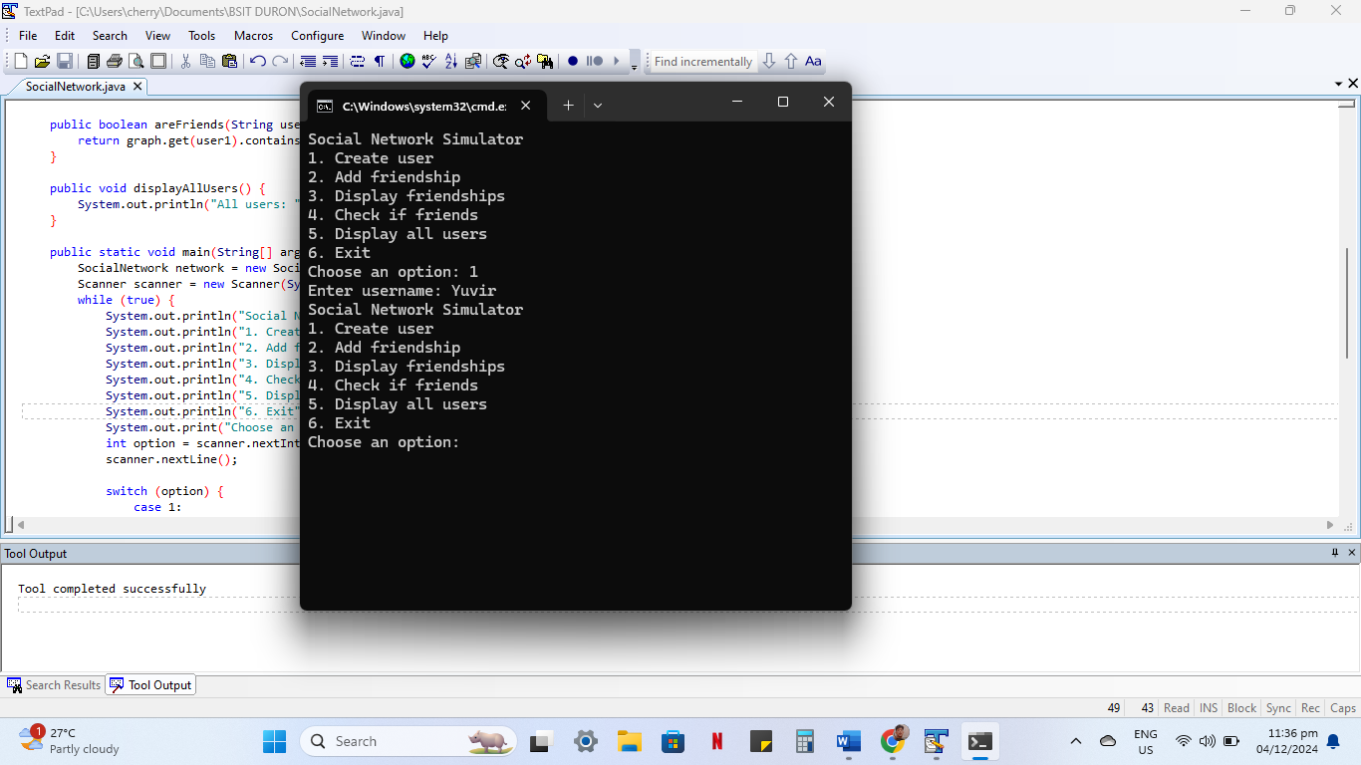

**Why I made this application**

I created this application to demonstrate my understanding of graph data structures and their application in real-world scenarios.

**How it contributes**

1. Provides a simple example of graph usage.

2. Helps users understand graph concepts.

3. Can be expanded to include additional features.